SYSTEM ARCHITECTURE AND MODULE DESCRIPTION
Deep Learning-Based Thermal Fault Detection
1. System Overview
The proposed system is an intelligent thermal-image processing framework designed to analyze thermal images of electrical and industrial equipment and identify abnormal thermal patterns. The architecture follows a pipeline in which thermal images are acquired, preprocessed, analyzed using deep learning, classified into normal or faulty conditions, and optionally localized to identify abnormal hotspot regions. The final results can be used for condition monitoring and future predictive maintenance applications.
2. Flowchart
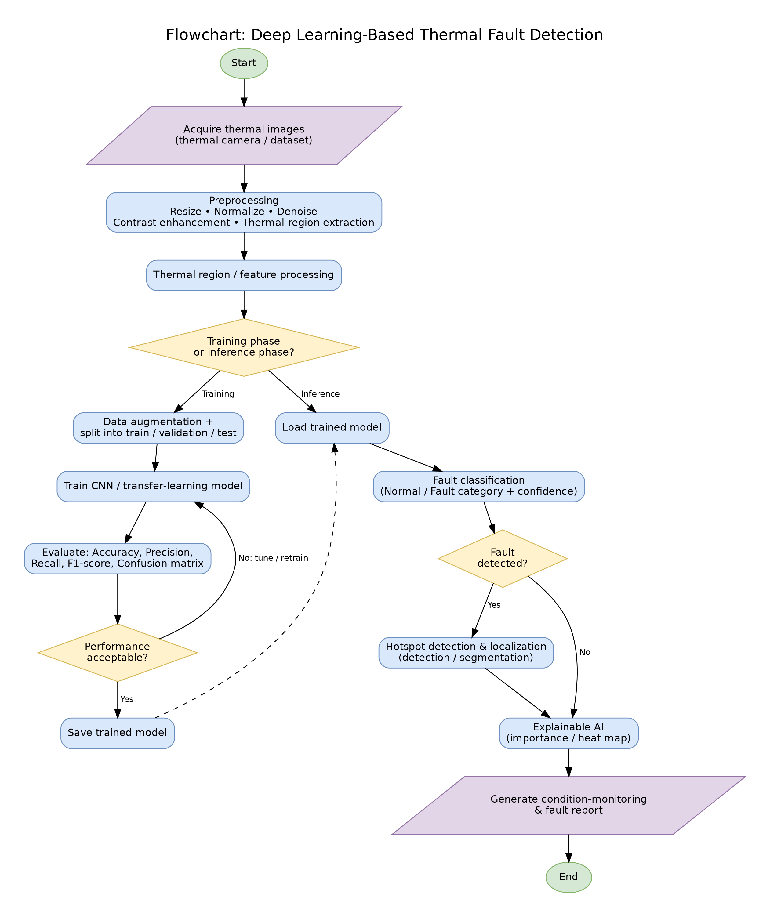

3. UML Class Diagram
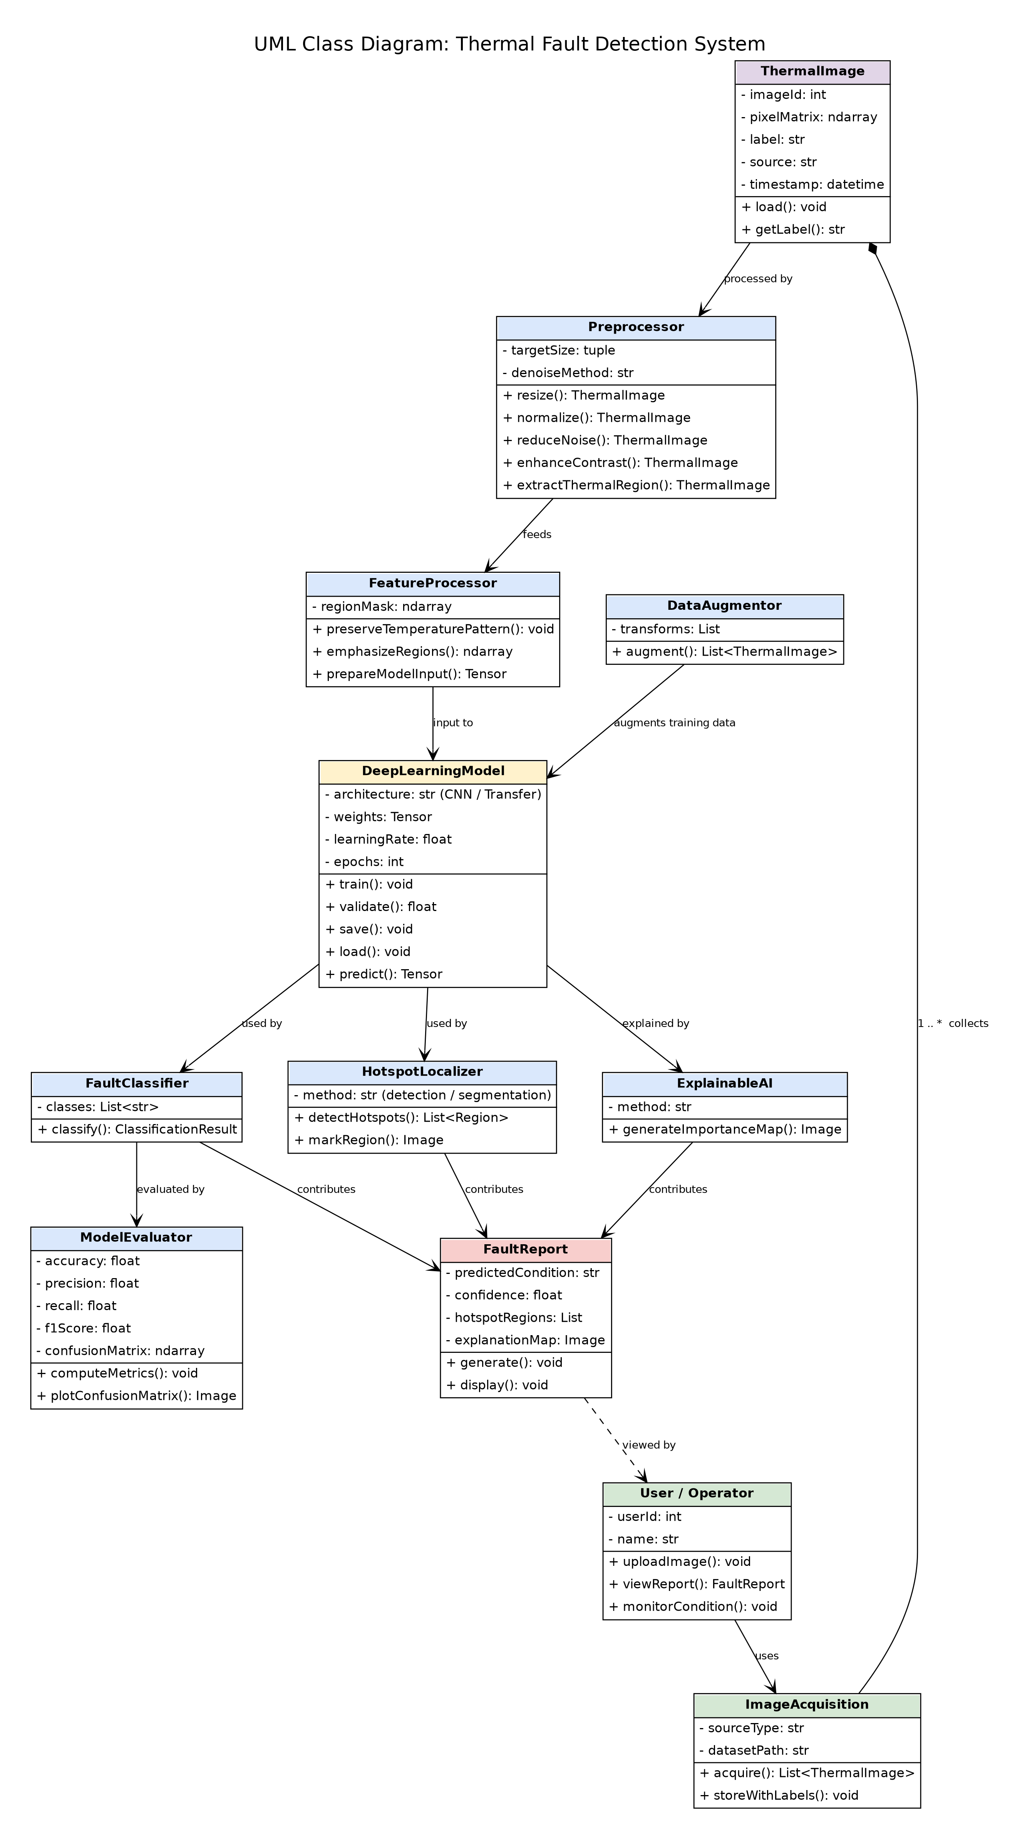

4. DFD Diagram
Level 0
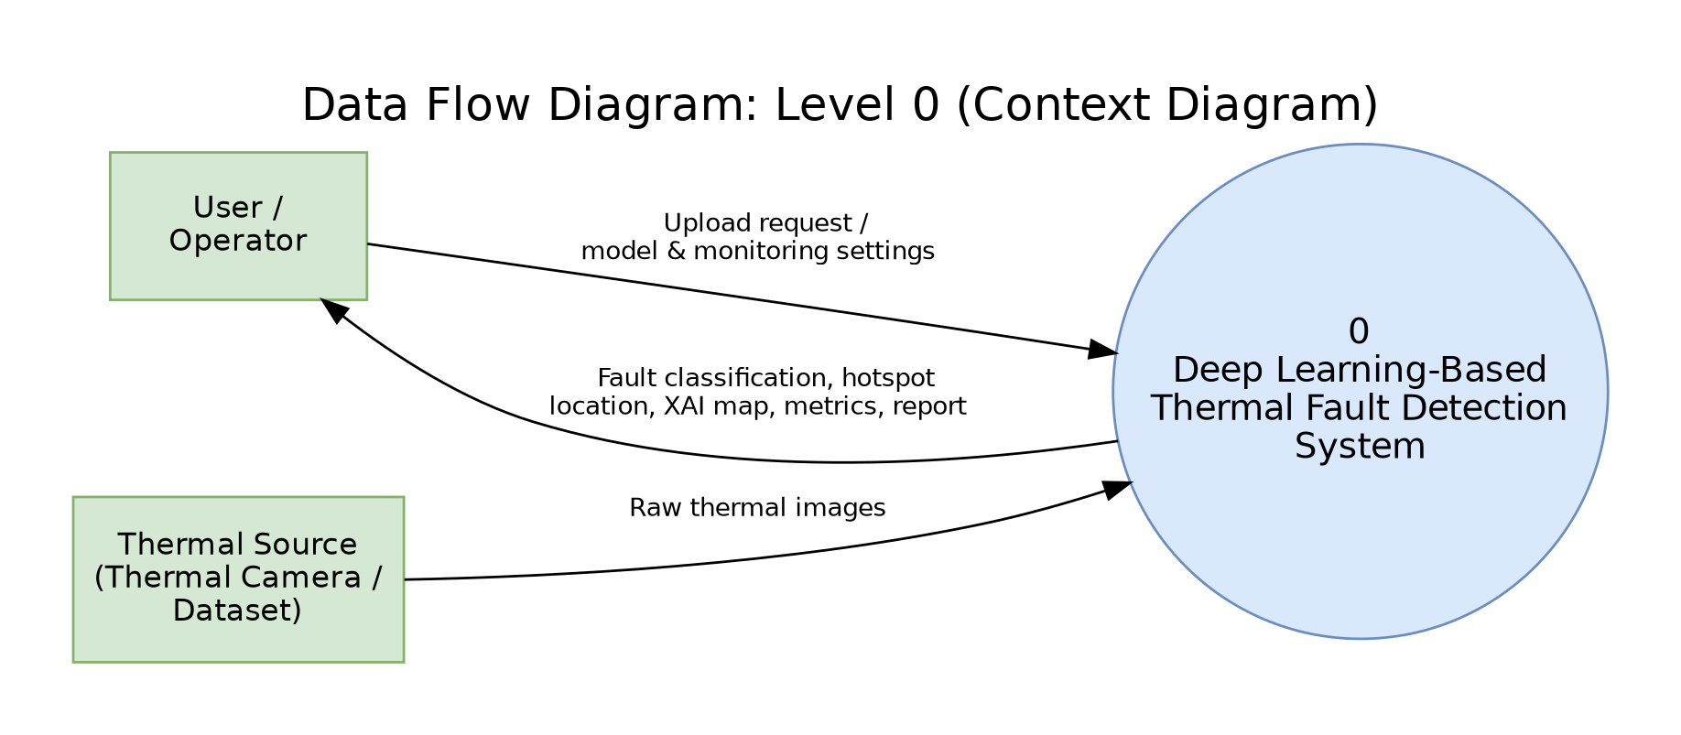

Level 1
